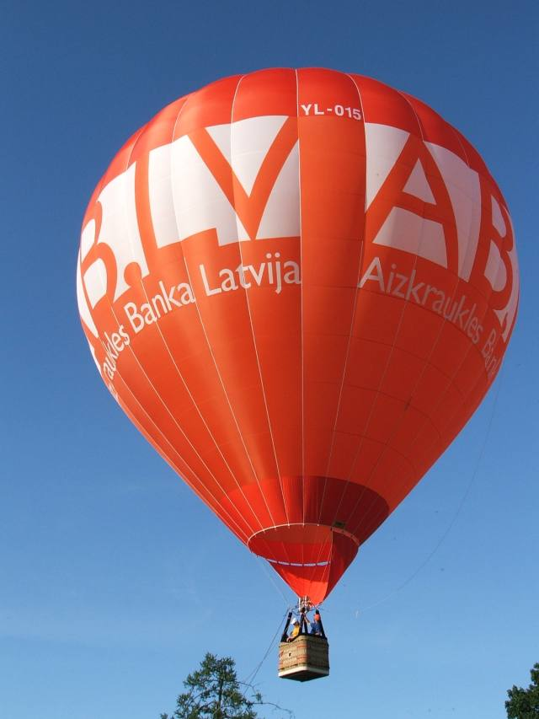
April, 2007

Dear Pilot,

We are glad to inform you that this year old tradition continues with a new main sponsor: AB.LV and hopefully ongoing competition “AB.LV CUP 2007” in one of the biggest cities of Latvia – Valmiera, July 11-15.

We invite you to 8th International Competition “AB.LV CUP 2007” in Valmiera, July 11-15. We will use rules based on FAI AXMERG Category 1. The winners in this year will be rewarded with following prizes:
1st place 1000 EUR and AB.LV CUP !!!
2nd place 700 EUR
3rd place 500 EUR

The organizers will provide for pilot + 3 crew:

- LPG
- Maps
- Meteo information
- GPS loggers
- Accommodation
- Morning coffee & 1 meal per day
- Welcome and farewell parties and other social events

We can provide all above mentioned for extra crew members for 80 EUR per person.
Official language – English.

This year we have limited number of participants - 25 balloons.

PAYMENTS:
There is entry fee EUR 50 that must be paid by June 22nd, 2007.
Returnable deposit of EUR 150 to be paid at the registration and will be returned after the last competition flight.

Please, fill in the entry form and return to us till 22nd of June. The applications will be accepted on first come, first serve basis, but only after receipt of entry fee.

Attached you will find more information on event and bank details for participation fee payment.

We look forward for your visit to Latvia, VALMIERA!

Sincerely yours,

Uldis Dumins  Event director  Ph. +371 2 937 24 24 | Kaspars Stamurs  Organiser’s club president

GENERAL INFORMATION
Main Sponsor AIZKRAUKLES BANKA

Organizer Balloon club “99 GAISA BALONI”
Event Director Uldis Dumins

Correspondence Uldis Dumins,
Balloon club “99 GAISA BALONI”
Riga, Bernatu str. 1, LV-1014, LATVIA
Phone: +371 2 937 24 24, +371 2 980 23 73
Fax: +371 6 7295012
E-mail: uldis@balloon.lv
http://www.balloon.lv

Officials Competition director – Eugenijus Komas

Location City Valmiera (www.valmiera.lv)

Participation requirements:
Entry deposit 50 EUR, entry deadline 22nd of June, 2007,
Deposit has to be transferred to:
Beneficiary: “99 gaisa baloni” sporta klubs, reg.nr.40008064917
Bank name: A/S “HANSABANKA”
Account No: LV 52 HABA 055 100 4950 155
S.W.I.F.T.: HABALV22
Address: Kalku str. 26, Riga, LV-1050, Latvia
Phone: +371 702 45 55
Pilot experience minimum 30 flight hours,
Valid insurance certificate for the period of event of 1 000 000 EUR third party liability and 100 000 EUR per passenger

Documents to show at registration:
Passport or ID Card, valid Pilot Licence, Pilot Logbook, Balloon registration Certificate, Certificate of Airworthiness, Insurance certificate

Common launch field:
Valmiera city, Divalina meadow (between following streets: Lucas street, Palejas street and Divalina street)

Accommodation:
Hotel “Naktsmajas” (www.naktsmajas.lv) – Vaidavas street 15, Valmiera
Contacts: info@naktsmajas.lv, ph. +371 6 4201200
Student hostel of University of Vidzeme – Ausekla street 25a, Valmiera
Contacts: ph. +371 2 9487109

More detailed information (electronic maps and detailed information on competition) will be provided closer to the event.

Schedule
(preliminary)

JULY 11 (Wednesday)
12⁰⁰ – 16⁰⁰ check in
until 18⁰⁰ gas refueling
17⁰⁰ general briefing
18⁰⁰ evening briefing and competition flight
21⁰⁰ – 24⁰⁰ gas refueling
22⁰⁰ welcome party, opening of the festival

JULY 12 (Thursday)
5⁰⁰ morning coffee, briefing, competition flight
8⁰⁰ – 11⁰⁰ gas refueling
9⁰⁰ – 11⁰⁰ breakfast
free time
15⁰⁰ city sight seeing - excursion
18⁰⁰ evening briefing and competition flight
21⁰⁰ – 24⁰⁰ gas refueling

JULY 13 (Friday)
5⁰⁰ morning coffee, briefing, competition flight
8⁰⁰ – 11⁰⁰ gas refueling
9⁰⁰ – 11⁰⁰ breakfast
free time / event at the lake + barbecue
18⁰⁰ evening briefing and competition flight, possibly Key Grab task
21⁰⁰ – 24⁰⁰ gas refueling
~23⁰⁰ night glow

JULY 14 (Saturday)
5⁰⁰ morning coffee, briefing, competition flight
8⁰⁰ – 11⁰⁰ gas refueling
9⁰⁰ – 11⁰⁰ breakfast
free
18⁰⁰ evening briefing and competition flight
21⁰⁰ – 24⁰⁰ gas refueling
~23⁰⁰ “AB.LV CUP 2007” awards ceremony &
Closing banquet – closed evening for participants, supporters and partners, live music

JULY 15 (Sunday)
6⁰⁰ briefing, fun flight
Departure

PILOT ENTRY FORM

Please use capital letters

PILOT:
Family Name |  |  |  |  | First Name
Date of Birth
Address for correspondence
 |  |  |  |  | Country
Phone No |  |  |  |  | Fax No
E-mail Address
Pilot Licence No |  |  |  |  | Valid till
Place and date of issue
P.I.C. hours
Number of crew members
BALLOON
Name |  |  |  |  | Registration No
Type/Size |  |  |  |  | Manufacturer
Certificate of Airworthiness No |  |  |  |  |  |  |  | Valid till
Insurance |  | Insurance company: |  |  |  |  |  | Valid till:
ACCOMODATION REQUIREMENTS
Date of arrival |  |  |  |  |  | Date of departure
Rooms required | Twin rooms |  |  |  |  | Single rooms
EXTRA REQUIREMENTS
If you have any requirements for extra crew, equipment, vehicles etc, please contact the organisers.

SIGNATURE ___________________________ DATE _____________________________

Please return by 22nd of June 2007, to: Mr. ULDIS DUMINS
SK “99 gaisa baloni”
Riga, Stabu 49a-24
LV-1011, LATVIA
Phone: +371 2 937 24 24, +371 2 980 23 73
Fax: +371 6 7295012
E-mail: uldis@balloon.lv
http://www.balloon.lv

